Hypothesis: More identifiability issues when kappa as a random walk has low variance:

Seed = 559, tau.rw = 1/0.5\*\*2:

Very good results:

achine generated alternative text:



Seed = 559, tau.rw = 1/0.1\*\*2:

Takes longer to converge, not as good results, clearly lower precision, a bit worse accuracy.

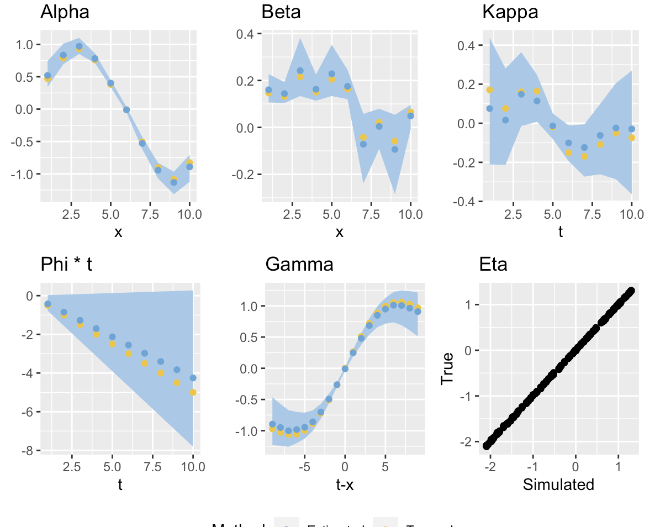

Seed = 558, tau.rw = 1/0.5\*\*2:

Ok, but a bit worse:

lpha 
1.0- 
0.5- 
0.0- 
-0.5 - 
-1.0- 
2.5 
Phi 
0.0- 
-2.5 - 
-5

Seed = 558, tau.rw = 1/0.1\*\*2:

Takes longer to converge, similarily good (bad) results, a bit lower precision and accuracy.

lpha 
1.0- 
0.5- 
o.o- 
-0.5 - 
-1.0- 
2.5 
Phi 
2.5 
Beta 
0.4 -

Seed = 557, tau.rw = 1/0.5\*\*2:

Quite good, phi is still the worst...:

achine generated alternative text:



Seed = 557, tau.rw = 1/0.1\*\*2:

Takes longer to converge, but does converge:

Better result than for high variance. Better accuracy, but worse precision.

lpha 
1.0- 
0.5- 
0.0- 
-0.5 - 
-1.0- 
2.5 
Phi 
2.5 
Beta 
0.3- 

Seed = 556, tau.rw = 1/0.5\*\*2:

Also not very good, but at least phi is within confidence band...

lpha 
1.0- 
0,5- • 
0.0- 
-0.5 - 
-1.0- 
2.5 
Phi 
2.5 
Beta 
7.5

Seed = 556, tau.rw = 1/0.1\*\*2:

Takes much longer time to converge!!! Sign of trouble finding global minimum:O Konvergerte ikke etter to runder.

Litt mer usikkerhet, men ikke veldig mye dårligere enn den med høy varians.

lpha 
1.0- 
0.5- 
0.0- 
-0.5 - 
-1.0- 
2.5 
Phi 
0.0- 
-2.5 - 
-5